Mesh-Star Topology

What Is Mesh-Star Topology?
# Source: AI Source: Provided by: [Data Path: Persons Table -> ID Column: 1, Name_En Column: Motasem Essam] -> From: [ChatGPT] on [12/18/2025]
A Mesh-Star Topology is a hybrid network topology that combines elements of both Mesh and Star layouts. It provides the reliability and redundancy of a mesh network at the core, and the simplicity and scalability of star topologies at the edge.

🧠 Simple Definition:
# Source: AI Source: Provided by: [Data Path: Persons Table -> ID Column: 1, Name_En Column: Motasem Essam] -> From: [ChatGPT] on [12/18/2025]
In a Mesh-Star topology, the core (backbone) of the network is built using mesh connections between key devices (like switches or routers), while individual groups of end devices are connected using star topologies.

🖼️ Visual Example:
# Source: AI Source: Provided by: [Data Path: Persons Table -> ID Column: 1, Name_En Column: Motasem Essam] -> From: [ChatGPT] on [12/18/2025]
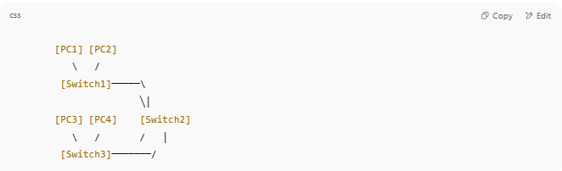
[PC1] [PC2]
\ /
[Switch1]─────\
╲│
[PC3] [PC4] [Switch2]
\ / / │
[Switch3]───────/

- Each switch uses a star topology to connect local devices.
- The switches/routers themselves are connected in a mesh pattern.

✅ Advantages
# Source: AI Source: Provided by: [Data Path: Persons Table -> ID Column: 1, Name_En Column: Motasem Essam] -> From: [ChatGPT] on [12/18/2025]
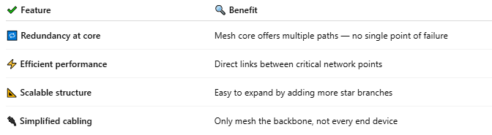

✔ Feature | 🔍 Benefit
🔁 Redundancy at core | Mesh core offers multiple paths — no single point of failure
⚡ Efficient performance | Direct links between critical network points
📐 Scalable structure | Easy to expand by adding more star branches
🔌 Simplified cabling | Only mesh the backbone, not every end device

❌ Disadvantages
# Source: AI Source: Provided by: [Data Path: Persons Table -> ID Column: 1, Name_En Column: Motasem Essam] -> From: [ChatGPT] on [12/18/2025]
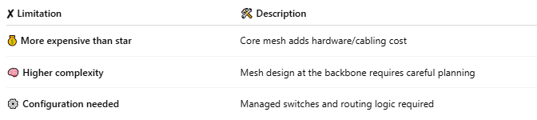

✘ Limitation | 🛠 Description
💰 More expensive than star | Core mesh adds hardware/cabling cost
🧠 Higher complexity | Mesh design at the backbone requires careful planning
⚙️ Configuration needed | Managed switches and routing logic required

🛠️ Use Cases
# Source: AI Source: Provided by: [Data Path: Persons Table -> ID Column: 1, Name_En Column: Motasem Essam] -> From: [ChatGPT] on [12/18/2025]
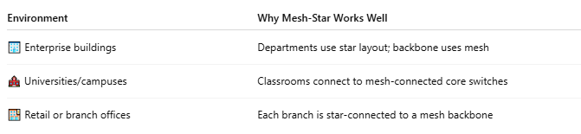

Environment | Why Mesh-Star Works Well
🏢 Enterprise buildings | Departments use star layout; backbone uses mesh
🏫 Universities/campuses | Classrooms connect to mesh-connected core switches
🏬 Retail or branch offices | Each branch is star-connected to a mesh backbone

✅ Summary
# Source: AI Source: Provided by: [Data Path: Persons Table -> ID Column: 1, Name_En Column: Motasem Essam] -> From: [ChatGPT] on [12/18/2025]
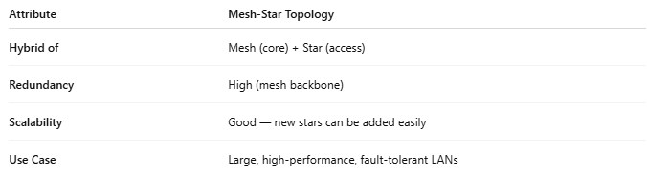
Attribute | Mesh-Star Topology
Hybrid of | Mesh (core) + Star (access)
Redundancy | High (mesh backbone)
Scalability | Good — new stars can be added easily
Use Case | Large, high-performance, fault-tolerant LANs

